Forecast the CocaCola Sales data set. Prepare a document for each model explaining how many dummy variables you have created and RMSE value for each model. Finally which model you will use for Forecasting.

**Ans :**

**R Code :**

## Forecasting Data Driven

########## CocaCola Sales Data Set #########

install.packages(c("forecast","fpp","smooth","tseries"))

library(forecast)

library(fpp)

library(smooth)

library(tseries)

library(readxl)

cocacolasales<-read_xlsx("D:\\Data Science\\Excelr\\Assignments\\Assignment\\Forecasting\\CocaCola_Sales_Rawdata.xlsx")

View(cocacolasales)

# Converting data into time series object

sales<-ts(cocacolasales$Sales,frequency = 4,start=c(86))

View(sales)

plot(sales)

# dividing entire data into training and testing data

train<-sales[1:38]

test<-sales[39:42] # Considering only 4 Quarters of data for testing because data itself is Quarterly

# seasonal data

# converting time series object

train<-ts(train,frequency = 4)

test<-ts(test,frequency = 4)

# Plotting time series data

plot(train) # Visualization shows that it has level, trend, seasonality => Additive seasonality

#### USING HoltWinters function ################

# Optimum values

# with alpha = 0.2 which is default value

# Assuming time series data has only level parameter

hw_a<-HoltWinters(train,alpha = 0.2,beta = F,gamma = F)

hwa_pred<-data.frame(predict(hw_a,n.ahead=4))

# By looking at the plot the forecasted values are not showing any characters of train data

plot(forecast(hw_a,h=4))

hwa_mape<-MAPE(hwa_pred$fit,test)*100

# with alpha = 0.2, beta = 0.1

# Assuming time series data has level and trend parameter

hw_ab<-HoltWinters(train,alpha = 0.2,beta = 0.1,gamma = F)

hwab_pred<-data.frame(predict(hw_ab,n.ahead = 4))

# by looking at the plot the forecasted values are still missing some characters exhibited by train data

plot(forecast(hw_ab,h=4))

hwab_mape<-MAPE(hwab_pred$fit,test)*100

# with alpha = 0.2, beta = 0.1, gamma = 0.1

# Assuming time series data has level,trend and seasonality

hw_abg<-HoltWinters(train,alpha = 0.2,beta = 0.1,gamma = 0.1)

hwabg_pred<-data.frame(predict(hw_abg,n.ahead = 4))

# by looking at the plot the characters of forecasted values are closely following historical data

plot(forecast(hw_abg,h=4))

hwabg_mape<-MAPE(hwabg_pred$fit,test)*100

# With out optimum values

hw_na<-HoltWinters(train,beta = F,gamma = F)

hwna_pred<-data.frame(predict(hw_na,n.ahead = 4))

hwna_pred

plot(forecast(hw_na,h=4))

hwna_mape<-MAPE(hwna_pred$fit,test)*100

hw_nab<-HoltWinters(train,gamma=F)

hwnab_pred<-data.frame(predict(hw_nab,n.ahead=4))

hwnab_pred

plot(forecast(hw_nab,h=4))

hwnab_mape<-MAPE(hwnab_pred$fit,test)*100

hw_nabg<-HoltWinters(train)

hwnabg_pred<-data.frame(predict(hw_nabg,n.ahead =4))

hwnabg_pred

plot(forecast(hw_nabg,h=4))

hwnabg_mape<-MAPE(hwnabg_pred$fit,test)*100

df_mape<-data.frame(c("hwa_mape","hwab_mape","hwabg_mape","hwna_mape","hwnab_mape","hwnabg_mape"),c(hwa_mape,hwab_mape,hwabg_mape,hwna_mape,hwnab_mape,hwnabg_mape))

colnames(df_mape)<-c("MAPE","VALUES")

View(df_mape)

# Based on the MAPE value who choose holts winter exponential tecnique which assumes the time series

# Data level, trend, seasonality characters with default values of alpha, beta and gamma

new_model <- HoltWinters(sales)

plot(forecast(new_model,n.ahead=8))

# Forecasted values for the next 4 quarters

forecast_new <- data.frame(predict(new_model,n.ahead=4))

forecast_new

######## ARIMA Model #############

# Converting data into time series object

sales<-ts(cocacolasales$Sales,frequency = 4,start=c(86))

View(sales)

plot(sales)

# dividing entire data into training and testing data

train<-sales[1:38]

test<-sales[39:42] # Considering only 4 Quarters of data for testing because data itself is Quarterly

# seasonal data

# converting time series object

train<-ts(train,frequency = 4)

test<-ts(test,frequency = 4)

plot(train)

acf(train)

pacf(train)

# Auto.Arima model on the price agg data

library(forecast)

model_AA <- auto.arima(train)

model_AA

pred_AA <- data.frame(forecast(model_AA))

acf(model_AA$residuals)

pacf(model_AA$residuals)

windows()

plot(forecast(model_AA,h=12),xaxt="n")

**Results :**

|  |  |  |  |  |  |  |  |  |  |  |  |  |  |  |  |  |  |  |  |  |  |  |  |  |  |  |  |  |  |  |  |  |
| --- | --- | --- | --- | --- | --- | --- | --- | --- | --- | --- | --- | --- | --- | --- | --- | --- | --- | --- | --- | --- | --- | --- | --- | --- | --- | --- | --- | --- | --- | --- | --- | --- |
| > hw_na<-HoltWinters(train,beta = F,gamma = F)  > hwna_pred<-data.frame(predict(hw_na,n.ahead = 4))  > hwna_pred  fit  1 4456.709  2 4456.709  3 4456.709  4 4456.709  > plot(forecast(hw_na,h=4))  > hwna_mape<-MAPE(hwna_pred$fit,test)*100  > hw_nab<-HoltWinters(train,gamma=F)  > hwnab_pred<-data.frame(predict(hw_nab,n.ahead=4))  > hwnab_pred  fit  1 4763.920  2 4946.695  3 5129.470  4 5312.244  > plot(forecast(hw_nab,h=4))  > hwnab_mape<-MAPE(hwnab_pred$fit,test)*100  > hw_nabg<-HoltWinters(train)  > hwnabg_pred<-data.frame(predict(hw_nabg,n.ahead =4))  > hwnabg_pred  fit  1 4876.456  2 4451.734  3 4353.283  4 5408.914  > plot(forecast(hw_nabg,h=4))  > hwnabg_mape<-MAPE(hwnabg_pred$fit,test)*100  > df_mape<-data.frame(c("hwa_mape","hwab_mape","hwabg_mape","hwna_mape","hwnab_mape","hwnabg_mape"),c(hwa_mape,hwab_mape,hwabg_mape,hwna_mape,hwnab_mape,hwnabg_mape))  > colnames(df_mape)<-c("MAPE","VALUES")  > View(df_mape)   | **MAPE** | | **VALUES** | | | --- | --- | --- | --- | |  |  | |  | | **1** | hwa_mape | | 16.126335 | | **2** | hwab_mape | | 8.928086 | | **3** | hwabg_mape | | 3.549841 | | **4** | hwna_mape | | 9.093032 | | **5** | hwnab_mape | | 8.627520 | | **6** | hwnabg_mape | | 2.397211 |   > new_model <- HoltWinters(sales)  > plot(forecast(new_model,n.ahead=8))  > # Forecasted values for the next 4 quarters  > forecast_new <- data.frame(predict(new_model,n.ahead=4))  > forecast_new  fit  1 5215.150  2 4672.568  3 4556.262  4 5630.019  > # Converting data into time series object  > sales<-ts(cocacolasales$Sales,frequency = 4,start=c(86))  > View(sales)  > plot(sales)  > # dividing entire data into training and testing data  > train<-sales[1:38]  > test<-sales[39:42] # Considering only 4 Quarters of data for testing because data itself is Quarterly  > # seasonal data  > # converting time series object  > train<-ts(train,frequency = 4)  > test<-ts(test,frequency = 4)  > plot(train)  > acf(train)  > pacf(train)  > # Auto.Arima model on the price agg data  > library(forecast)  > model_AA <- auto.arima(train)  > model_AA  Series: train  ARIMA(0,1,0)(0,1,0)[4]  sigma^2 estimated as 32602: log likelihood=-218.29  AIC=438.59 AICc=438.72 BIC=440.09  > pred_AA <- data.frame(forecast(model_AA))  > acf(model_AA$residuals)  > pacf(model_AA$residuals)  > plot(forecast(model_AA,h=12),xaxt="n") |
|  |
| |  | | --- | |  | |

**Plots :**

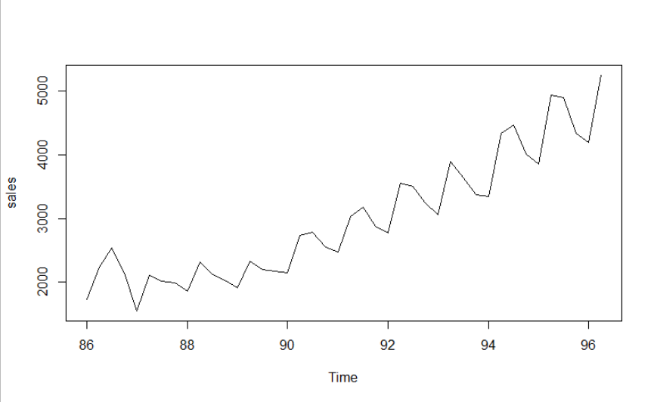

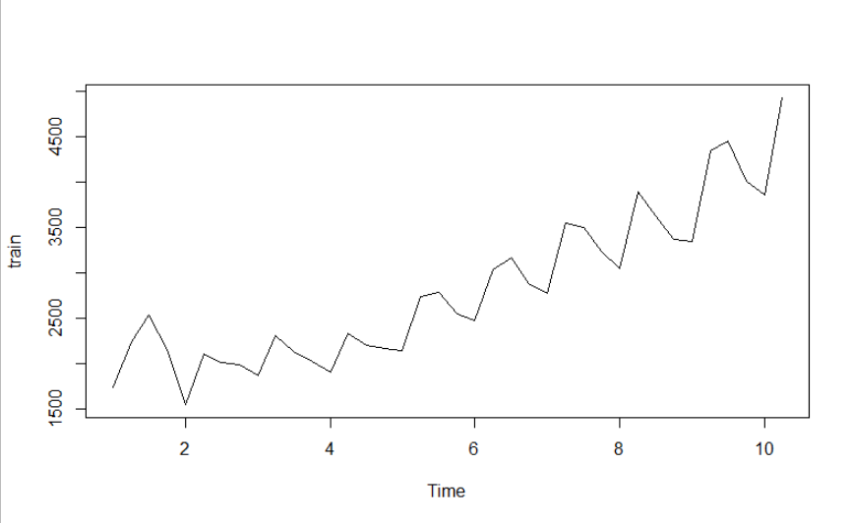

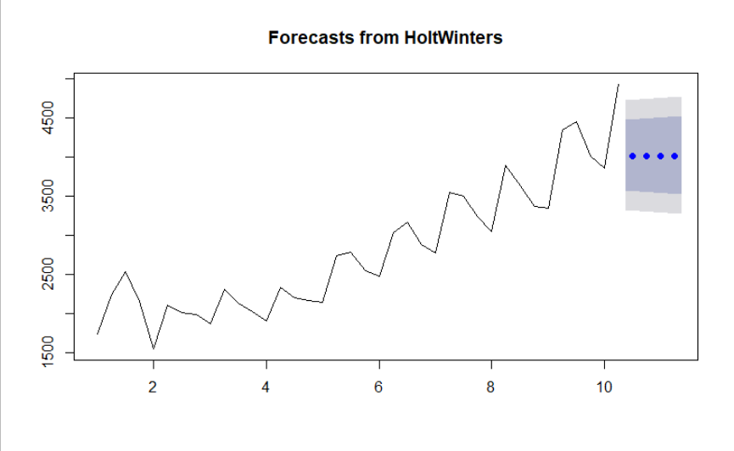

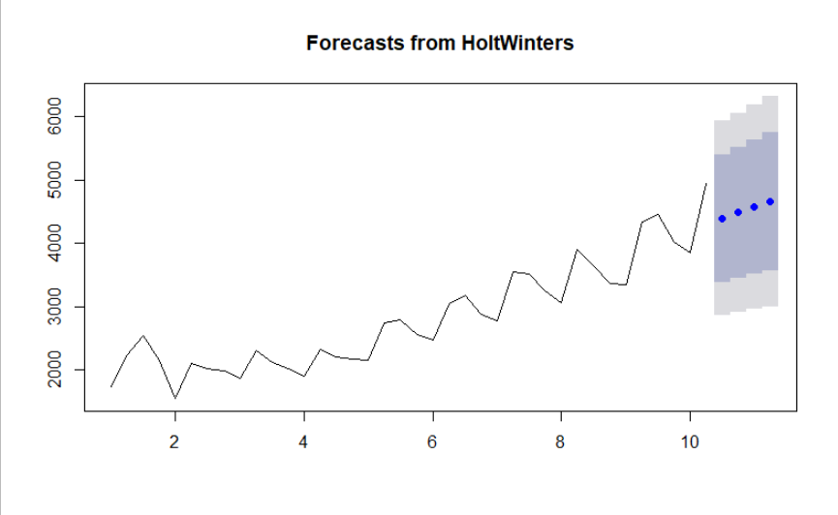

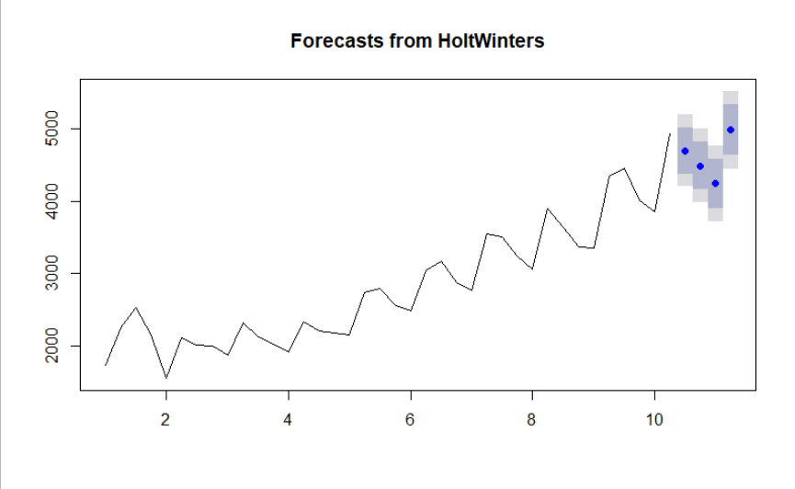

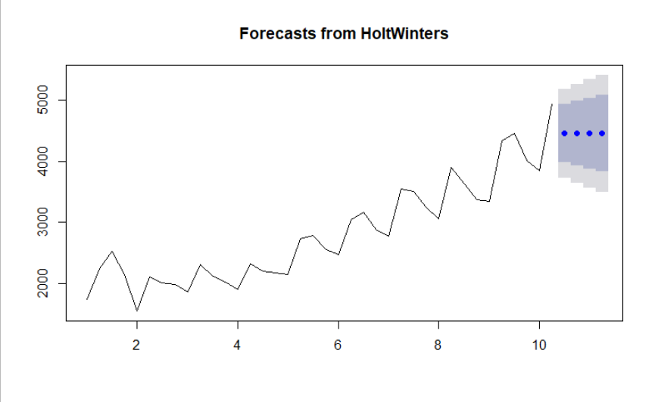

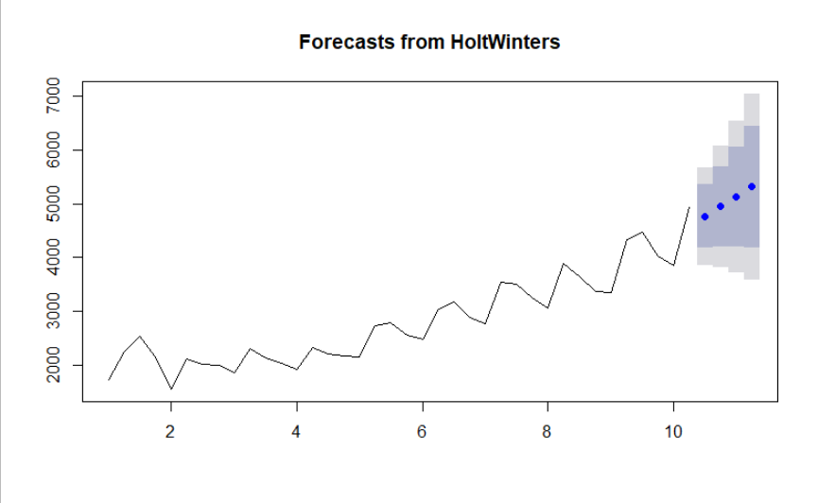

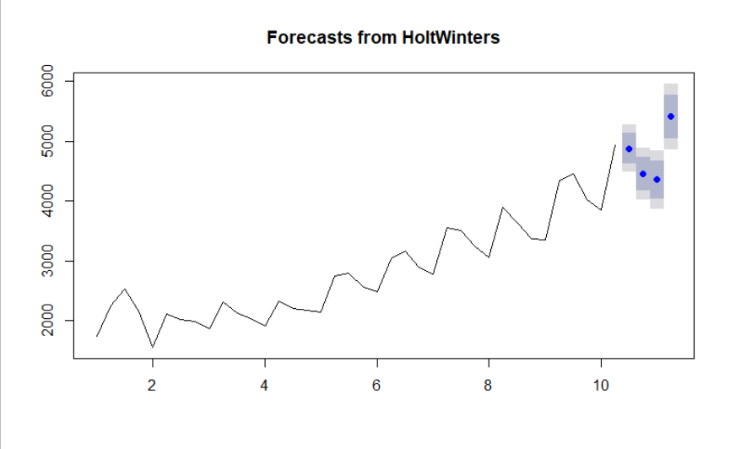

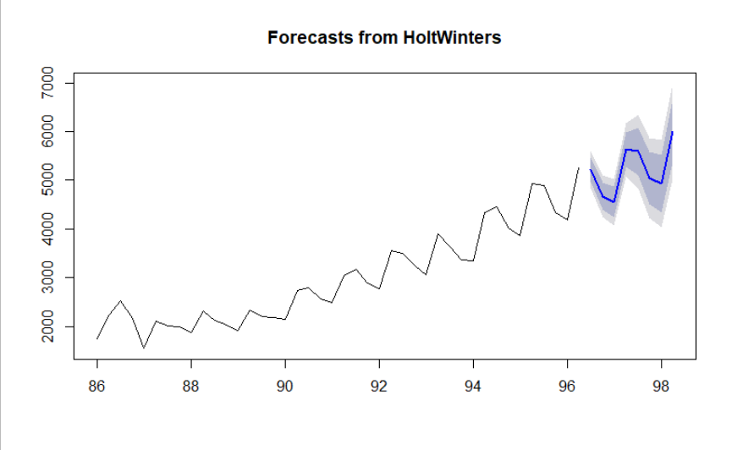





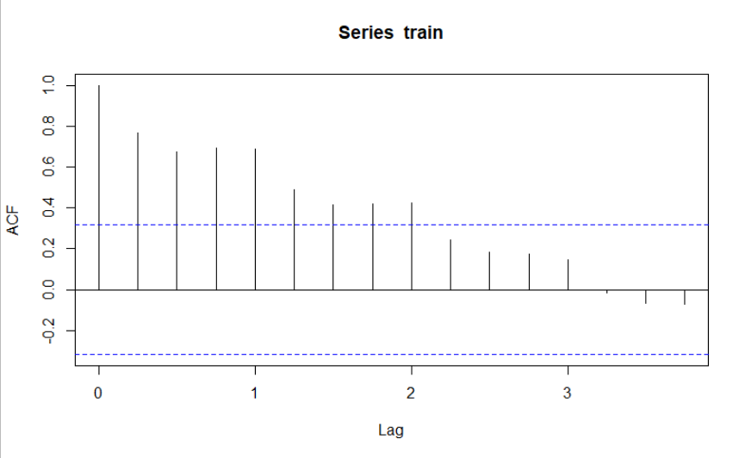

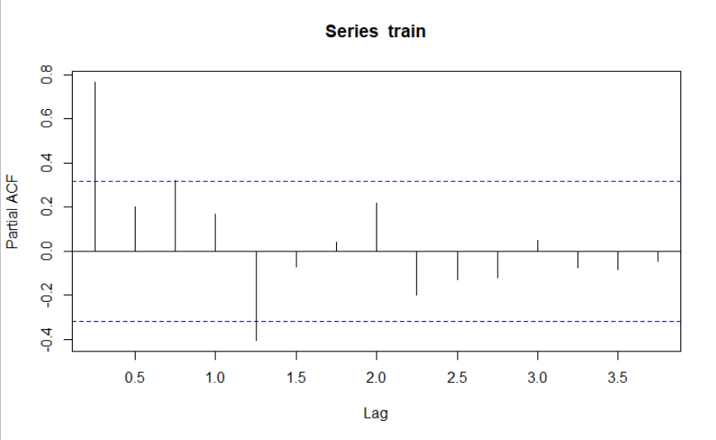

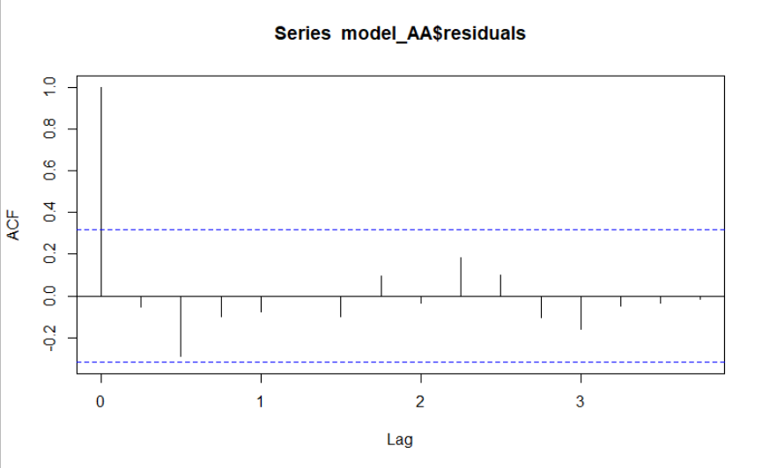

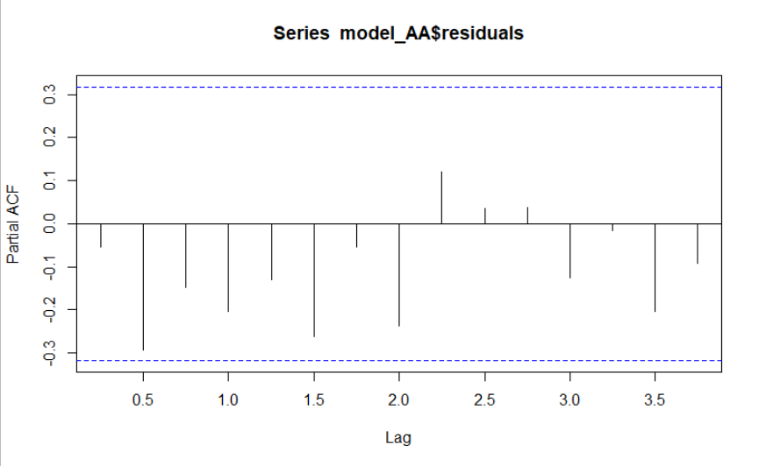

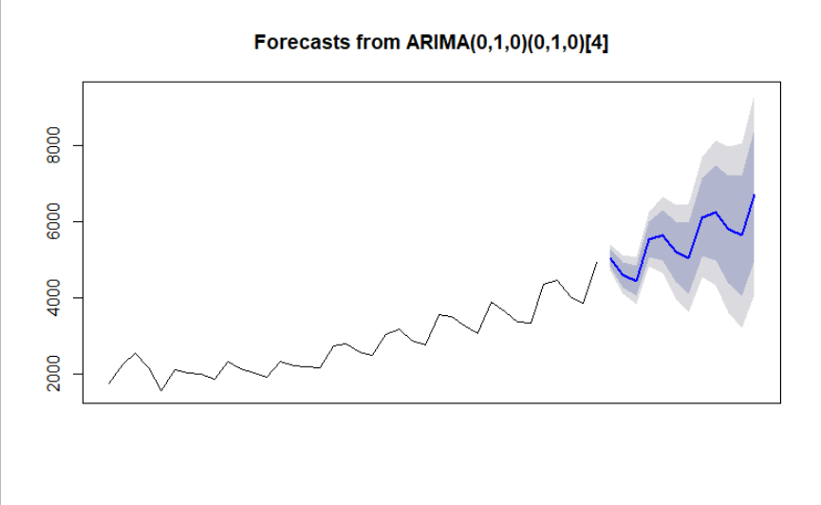

**Inference :**

The MAPE values of various models are as below :

| **MAPE** | | **VALUES** | |
| --- | --- | --- | --- |
|  |  | |  |
| **1** | hwa_mape | | 16.126335 |
| **2** | hwab_mape | | 8.928086 |
| **3** | hwabg_mape | | 3.549841 |
| **4** | hwna_mape | | 9.093032 |
| **5** | hwnab_mape | | 8.627520 |
| **6** | hwnabg_mape | | 2.397211 |